English book report
1/3

Title: Harry Potter and the Philosopher`s Stone
Writer: Joanne Kathleen Rowling
Genre: Adventure/Fantasy

Story:

Harrys parents gets killed by the evil wizard Voldemart when Harry is a baby. Voldemart is trying to kill Harry too but he fails beacause Harry is a special boy, he is a great wizard. After his parents have died he is got to live with the family Dursley. They are relatives with Harry. The Dursley family is very mean to him, for example he is forced to live under the stairs. When Harry is 11 years old he gets a letter from Hogwarts school. The letter is a inventation to Harry. He has been accepted to Hogwarts school. Hogwart is a school for wizards. He decides to go there. On the train to Hogwarts he meets Ron Weasley and Hermione Granger. Theese two persons are going to be his best freinds. When they arrive to Hogwarts they are being sorted in four gruops: Gryffindor Ravenclaw, Hufflepuff och Slytherin. Harry, Ron and Hermione joins Gryffindor. The four diffrent groups are competing with eachother in diffrent competions.

One day when Harry and his two friends are doing some spywork they discover a very big dog with three heads. The dog is about 5 meters high, and he is guarding something, something real important. Harry, Ron and Hermione begins to chat with people on Hogwarts. After while they understand what the dog is guarding, the the Philosopher`s Stone. If you got the Philosopher`s stone you will be imortal. And you can make gold of every metal on earth. The evil wizard Voldimore wants the stone very badly. Beacause he is sick and will die soon. And if he gets the stone he will be imortal.......
2/3
Main characters in the book:
Harry

Harry is eleven years old. He gots black hair and glasses. He’s got a scarf in his face that looks lika the letter N.

Ron Weasly
Ron Weasly

Ron comes from a poor family. He’s got red hair. He is tall and thin. He is a very loyal friend.

Hermione Granger

Is a very good wizard. Her spells often saves Harrys and Rons lifes. She got brown curly hair.

3/3
Environment description

Most part of the book take place on the school Hogwards. Hogward is an old castle who lies in the north of England.
It is very big.

My opinion about the book

I think this book was pretty good. It is written in a easy way, it’s easy to understand. I think this book is for people around eleven-thirteen. It’s one of the best adventure books i have read in a couple of months. I dont think I’m going to read the second Harry Potter book, they are so thick.

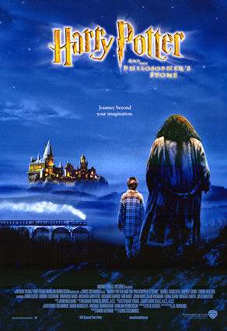
The book gets 3/5 possible ppossible

